09/23/22
4244 Shoreclub Drive Mercer Island, WA
This document serves to describe a few revisions that were made, aside from the corrections provided.
Summary of revisions since original submittal:
-Existing closet in mechanical room has been removed. Refer to A1.0 demo plan
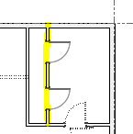

-Existing rock steps along east side yard have been removed. New steel stairs have been designed and included. Refer to new structural details on S3.3 and A2.0, A1.3

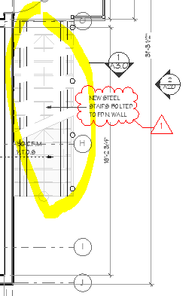

-Concrete trash pad/enclosure along east side yard was not originally included in the structural engineering package. Please refer to the addition of these details on S2.0 and S3.3
